
January 19, 2025

Zentalis Pharmaceuticals released updated data from three ongoing studies of azenosertib (oral WEE1i) in PROC and announced expansion of the ongoing P2 DENALI study to include a pivotal Part 2, potentially enabling a 2027 FDA accelerated approval in Cyclin E1+ PROC. (Event Announcement | Press Release | Presentation)

Key Takeaways:
- DENALI Part 2 will start in H1 2025 and is expected to disclose topline data before the end of 2026 with potential to support AA in 2027
  - Azenosertib was granted FDA Fast Track Designation in Cyclin E1+ PROC in January 2025
  - If successful, azenosertib approval could occur around the same time CI is predicting for Genmab’s Rina-S (FolRα Top1i) which is being studied in PROC all-comers
  - CI would like to caveat the likelihood of accelerated approval due to direct competition with Incyte: Incyte’s INCB123667 (oral CDK2i) has announced registrational study plans in the same Cyclin E1+ patient population, and Zentalis would lose accelerated approval path if the clinical trial timeline falls behind Incyte
- DENALI trial design:
  - Part 2 will study azenosertib in Cyclin E1+ PROC with 1-3 prior LOT and prior Elahere if FRα high
  - Part 2a will confirm the 400mg QD PO 5:2 (5 days on, 2 days off) vs 300mg QD PO 5:2 by enrolling ~30 PROC patients at each dose level
  - Part 2b will enroll ~70 patients at a single dose informed by 2a results; dose selection and endpoint will be subject to FDA feedback
  - The study will use a seamless design to allow continuous enrollment across Parts 2a and 2b
- Design of a P3 confirmatory study is pending FDA feedback, but is expected to begin in 2026

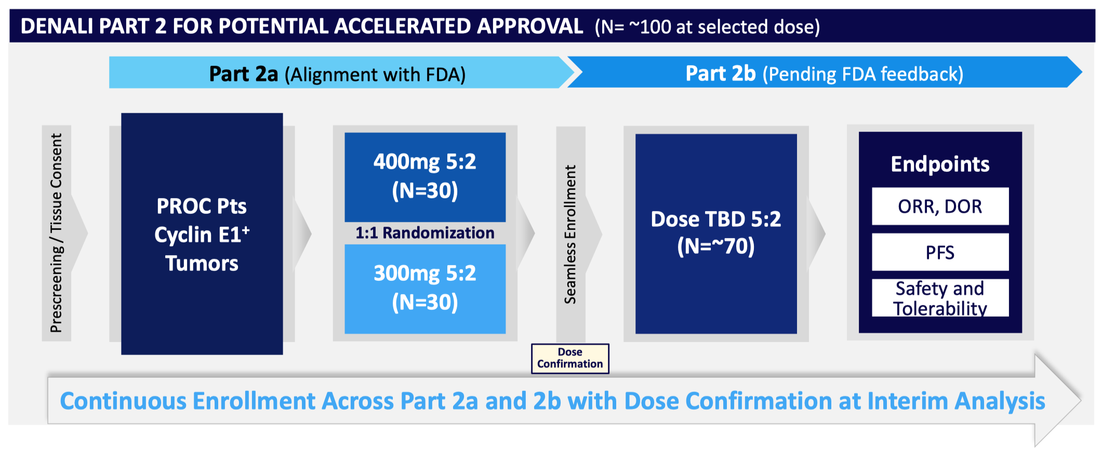
- Zentalis presented clinical data updates from three P1 and P2 studies of azenosertib, providing rationale for the approach of the pivotal study
- ORR >30% with a mDOR ~5 mos in a biomarker selected PROC population appears competitive with other datasets used to support current pivotal studies
- No new safety signals were observed since the last update in June 2024, when the FDA placed azenosertib on partial clinical hold due to Gr5 sepsis-related deaths in the DENALI trial; the clinical hold was subsequently lifted in Sept 2024
Trial Design | Efficacy | Safety
P1 ZN-c3-001 in solid tumors; mono azenosertib dose escalation in, 12/2/2 data cut-off | - ORR = 34.8% (8/23)  - mDOR = 5.2 mos  n = 23 pts; Cyclin E1+ PROC; intermittently dosed at daily dose levels ≥300mg | - Gr≥3 heme TRAEs: 13% neutropenia, 11.4% anemia, 10.9% thrombocytopenia  - 5.2% discontinuation  - One Gr 5 TRAE prev. reported  n = 193 pts, intermittently dosed at daily dose levels ≥300mg
P2 MAMMOTH in PARPi-resistant PROC; 300mg vs 400mg QD 5:2 dosing, 12/2/24 data cut-off | - ORR = 31.3% (5/16)  - mDOR = 4.2 mos  n=61 Cyclin E1+PROC treated at the 400mg QD 5:2 dose | - Safety consistent across doses, and with P1 results  - 5.6% discontinuation at 400mg  - One Gr 5 TRAE prev. reported
P2 DENALI Part 1b in PROC; 400mg QD 5:2 dosing and Cyclin E1 biomarker confirmation, 12/2/24 data cut-off | - ITT pts with Cyclin E1+ PROC: ORR = 31.3% (15/48)  - Cyclin E1+ PROC pts who were response-evaluable (received at least one scan) ORR = 34.9%; mDOR for the ITT = 5.5 mos (not mature) | - Safety consistent with P1 and MAMMOTH results  - 21.6% discontinuation  - Two Gr 5 TRAEs prev. reported

- Zentalis is also developing a proprietary Cyclin E1 IHC companion diagnostic for azenosertib
- The company noted that ~50% of PROC is Cyclin E1+ and ~20% is CCNE1 amplified

Potential Implications:
- Azenosertib is currently the most advanced WEE1 inhibitor in the clinic; if approved, it has the potential to become a first-in-class agent to treat PROC
- Part 2 of DENALI study design is Elahere step-through (i.e., only enroll FRα high PROC patients if they have previously received Elahere), reducing the potential of the study to recruit Elahere-eligible patients and the ability to provide head-to-head comparisons to Elahere (i.e., they could recruit Elahere patients in markets where Elahere is not yet available or reimbursed)
- Direct competition with Incyte’s oral CDK2i asset, casting challenges to Zentalis’s accelerated approval path: announcement of this pivotal study comes days after Incyte’s announcement of their registrational approach for INCB123667 (oral CDK2i) in Cyclin E1+ PROC; these two compounds are each other’s most important competitor, starting pivotal studies in the same patient population at the same time
- To extend Zentalis’ current cash runway to support DENALI Part 2 and potential azenosertib regulatory filings, Zentalis announced “strategic restructuring” that includes layoffs and pauses on other developmental programs; delays to the accelerated approval regulatory approach or requirement for a completed P3 study prior to approval may extend the study past the current cash runway
- Of note, Zentalis’s stock fell ~25% in the days following the company’s announcement, suggesting potential skepticism from investors about the asset’s future outlook

For questions, please reach out to:
International / OUS Affiliates: Maureen Nail
US: Chen Gao
Corporate Strategy, R&D and PCS: Colleen Plesac

This document/email contains competitive intelligence collected via an approved competitive intelligence supplier working on behalf of AbbVie. We collect competitive intelligence consistent with industry standards and AbbVie policy. Not for field distribution. Please reach out to IMABI, Legal, or OEC teams with any questions.

